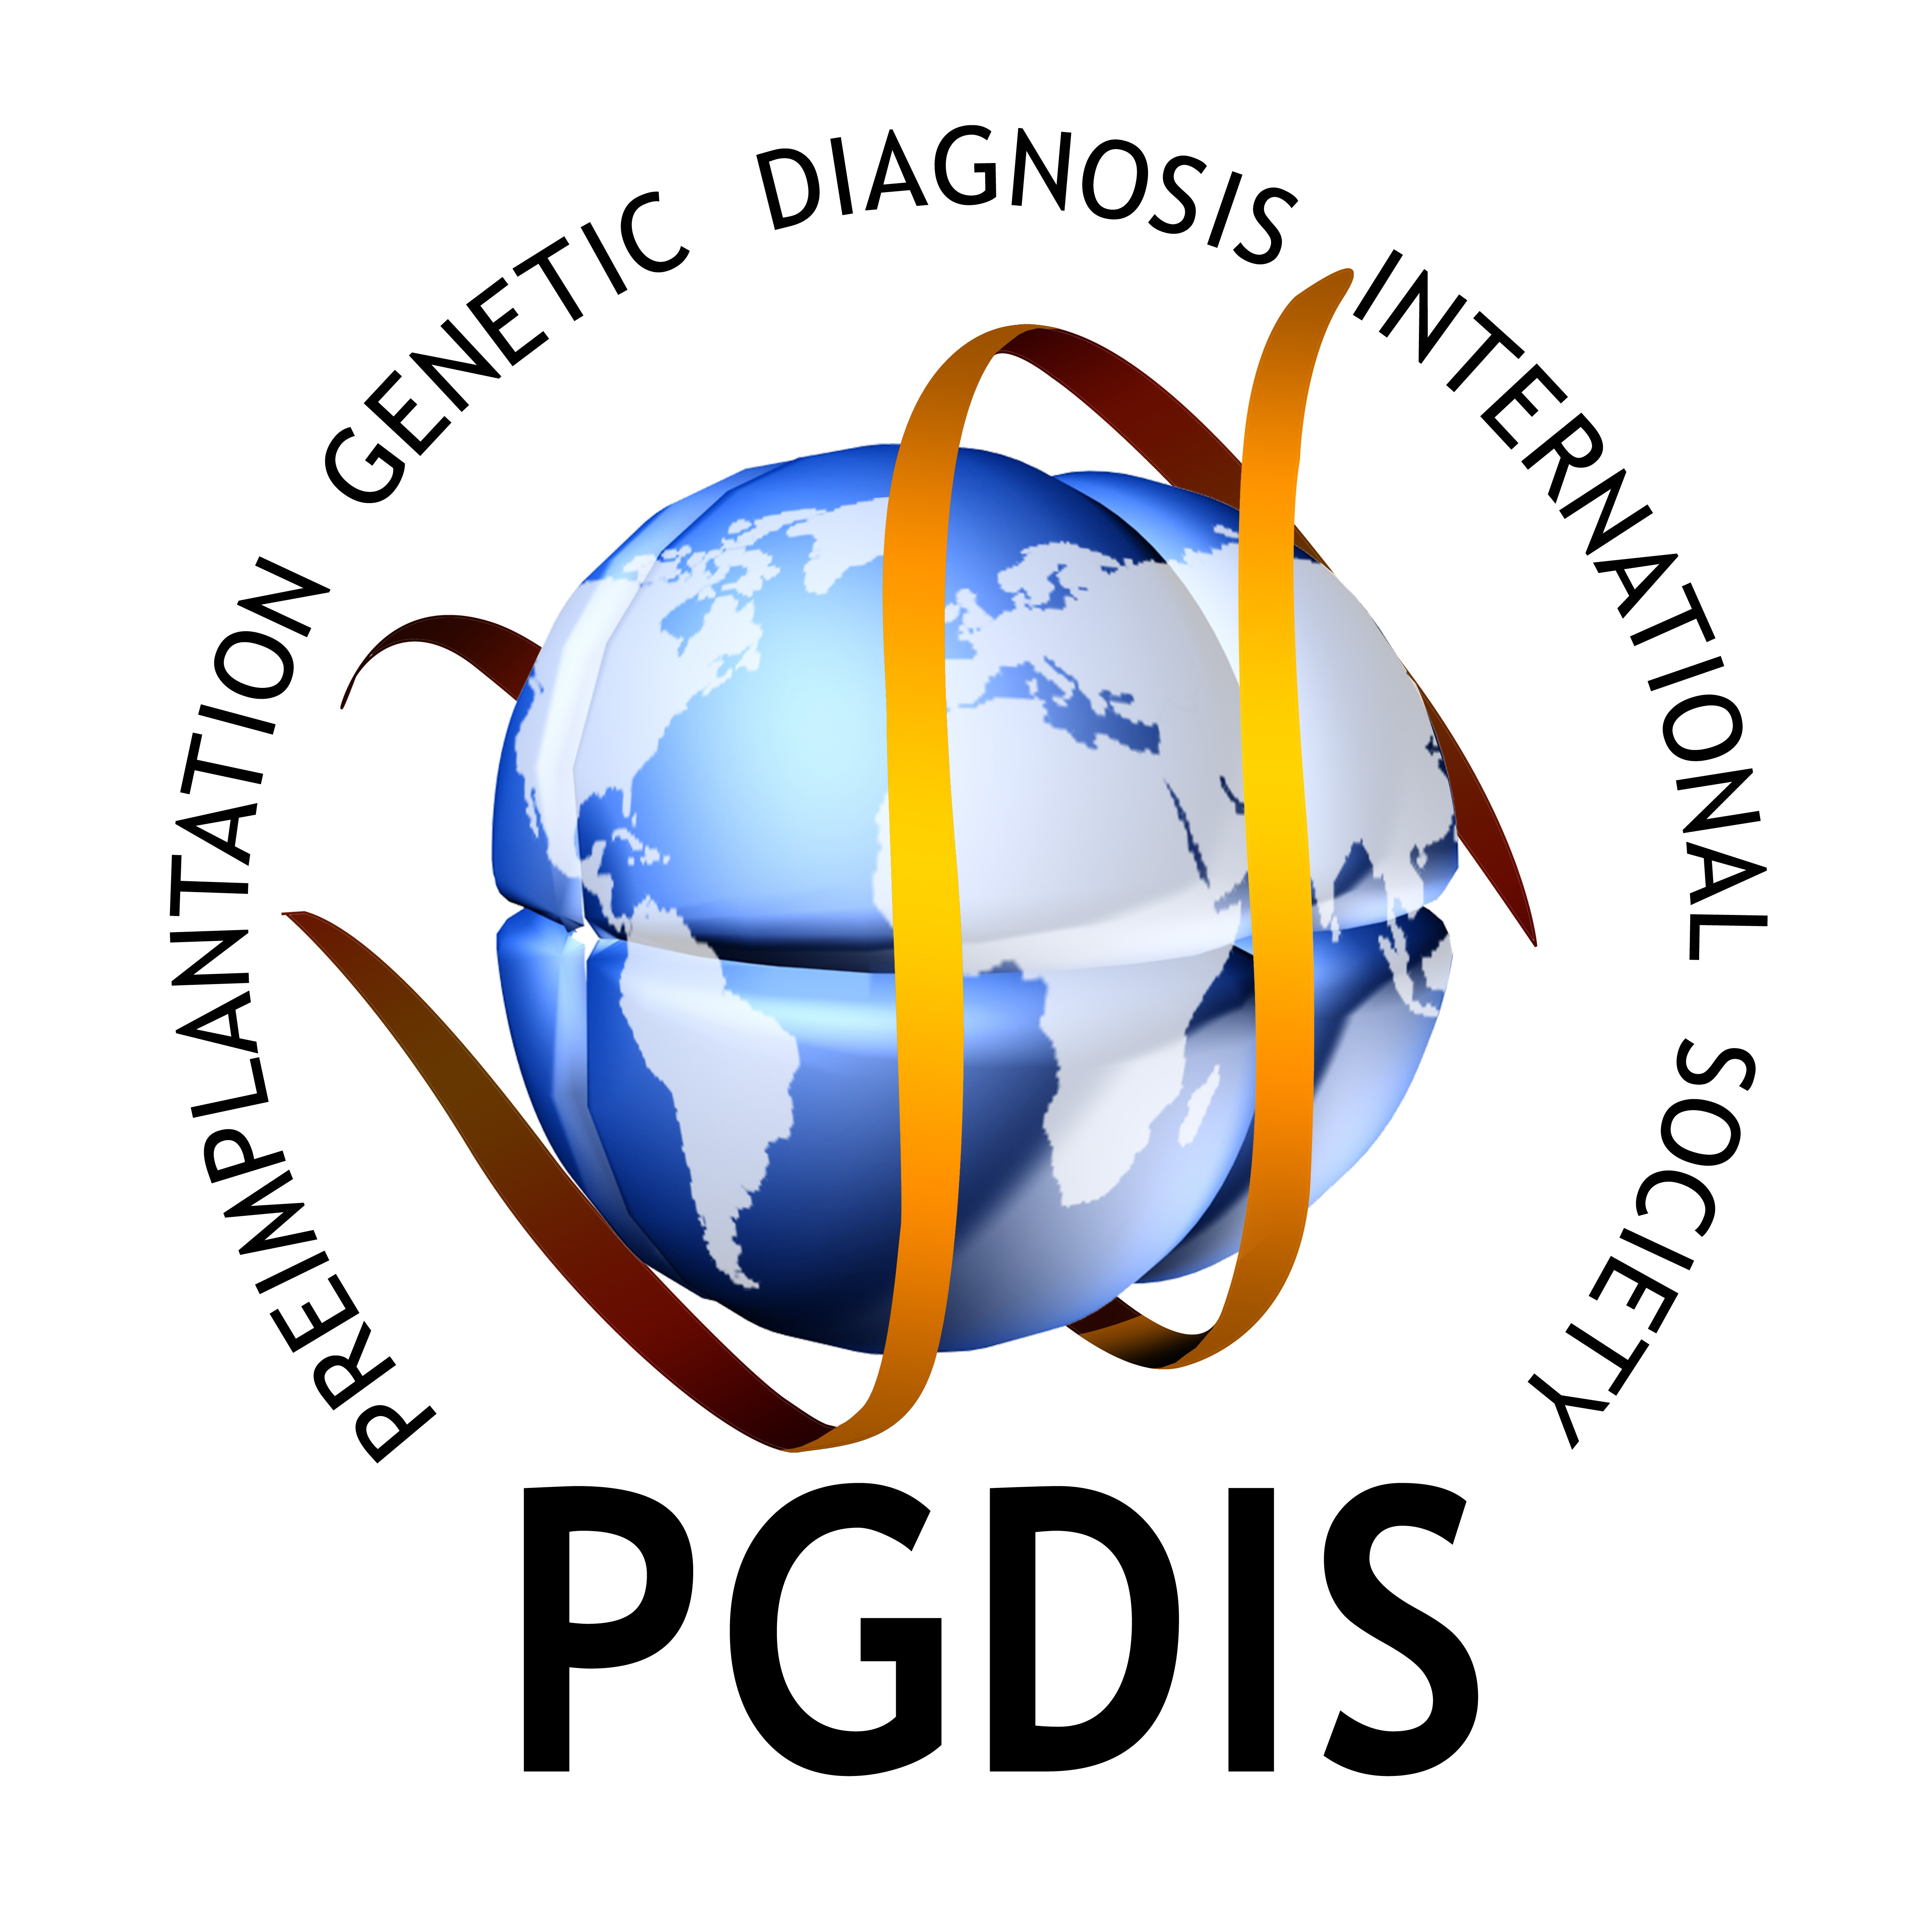
14th International Conference on
Preimplantation Genetic Diagnosis
May, 11-13, 2015, Chicago, USA
HOTEL BOOKING FORM

Please fill and send the form by e-mail to info@rgipgd.com or fax to +1 847 400 15 16

MR / MRS : TITLE

LAST NAME : FIRST NAME

INSTITUTION :

ADDRESS :

COUNTRY :

TELEPHONE : FAX

E-MAIL :

HOTEL BOOKING INFORMATION

Rahaelo (Conference Hotel)
Single room |  | USD 150, per room, per night
Double room |  | USD 150, per room, per night
Name of
Accompanying Person
Check in date
Check out date
Number of nights
Total amount

CONFIRMATION

Full payment is required for the accommodation. Upon receipt of the registration forms with the appropriate fees, confirmation will be sent within one week.

CANCELLATION

Cancellations prior to December 31, 2014 will involve the refund of 50% of the total accommodation. After December 31, 2014, no refund is possible.

PAYMENT OPTIONS

Bank transfer in USD: Bank transfer receipt must be sent to mail@rgipgdis.com and the name of the
participant must be mentioned clearly on the bank receipt. Please note that “all bank charges are to be paid by
the sender”.

Beneficiary :PGDIS Bank : PNC Bank,
Account # :603161772 Address: 4100 W. 150th Street, Cleveland, OH 44135
Routing number: 072000915 Swift Code: NATCUS33

Credit Card: As per my room reservation request, I hereby authorise my credit card to be debited as follows:

Total Amount
Type of the Card (please circle) | MasterCard / VISA / American Express
Bank
Cardholder Name
Credit Card No
Expiration Date
(MM/YY)
CVV (last 3 digit # at the back of the card)
Signature

HOTEL OPSIONS:

otel Options

